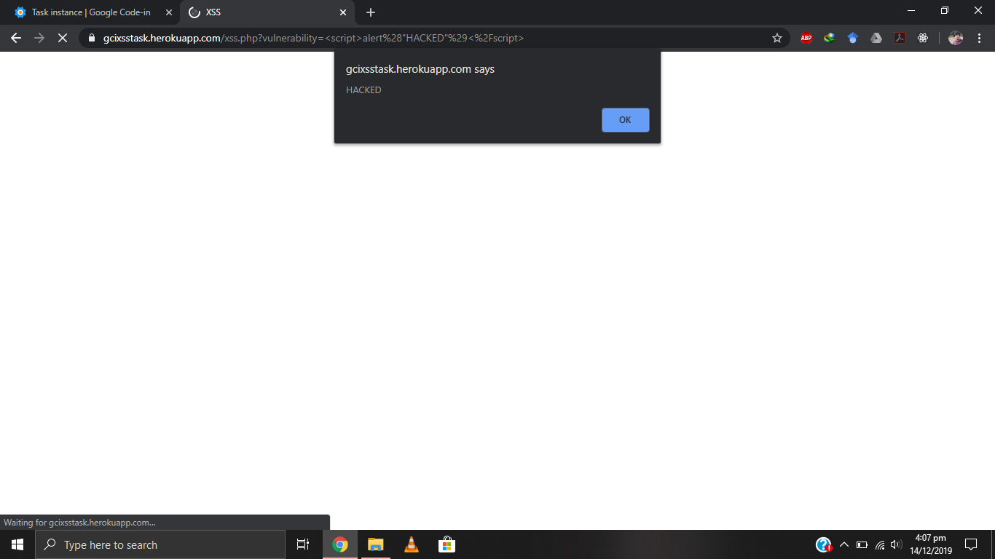

<script>alert(“HACKED”)</script>

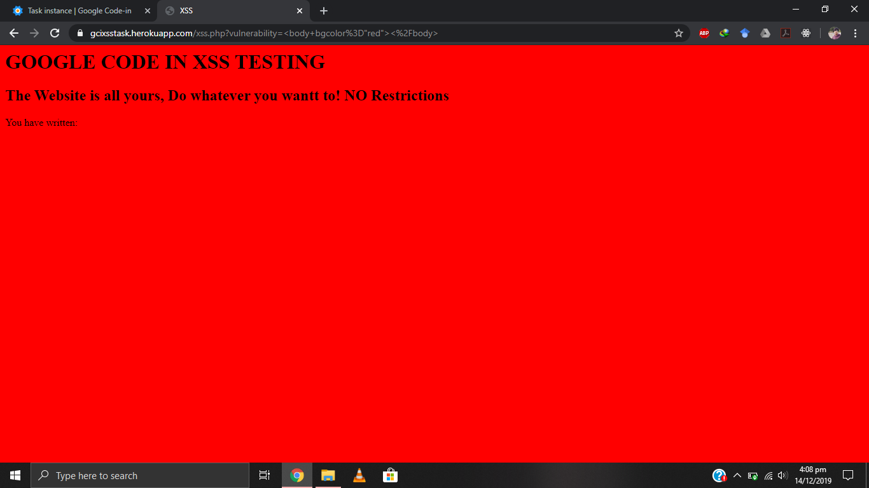

<body bgcolor="red"></body>

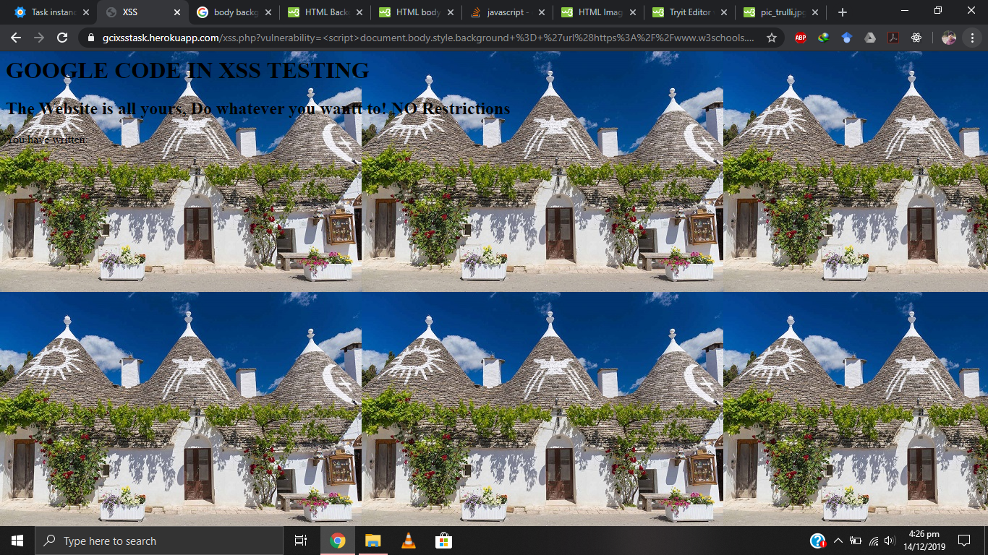

<script>document.body.style.background = 'url([https://www.w3schools.com/html/pic_trulli.jpg)'</script](https://www.w3schools.com/html/pic_trulli.jpg)'%3c/script)>

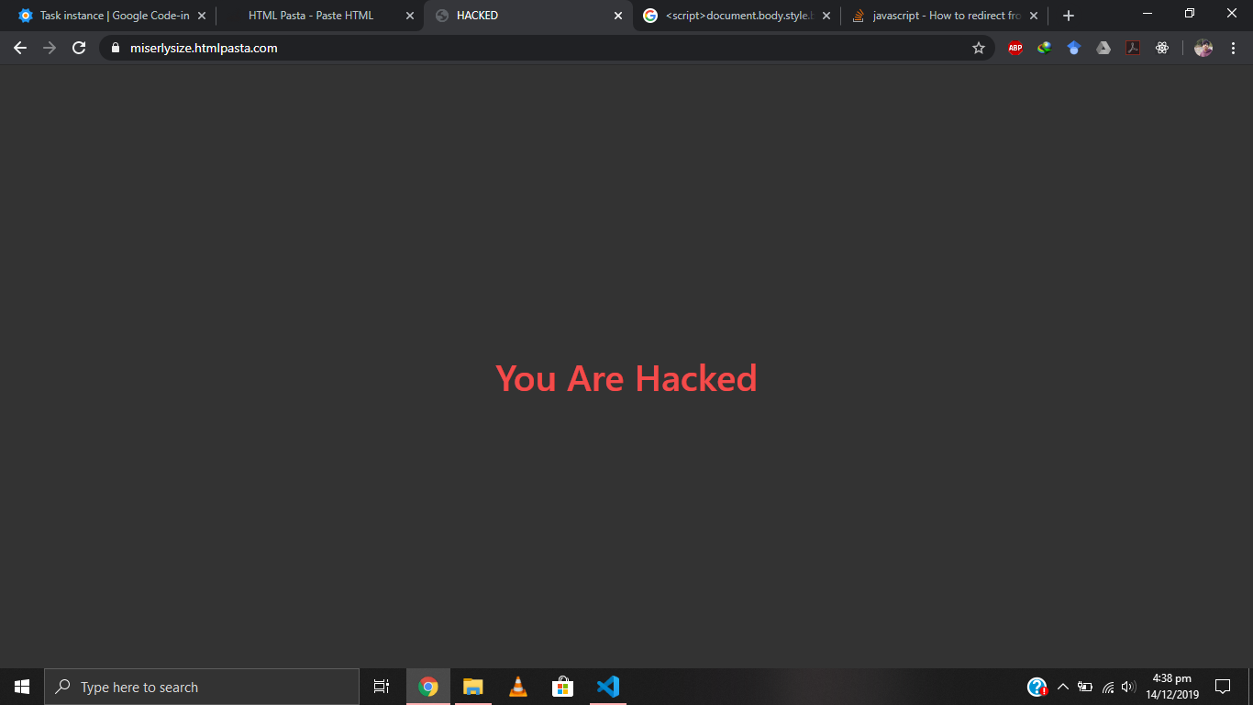

<script>window.location.href = "https://miserlysize.htmlpasta.com"</script>